NOS Report

- Student: Issam Awamleh
- Company: JODDB(Cyber shield)
- URN of NOS: TECDT611403
- Name of NOS: Respond to and Recover from OT Cybersecurity Incidents

**Performance criteria of the NOS and how you applied it in your company **
(Explain and include evidence from your work)
Performance Criteria Evidence
P1:Identify and triage OT cybersecurity incidents to determine severity, safety impact, and required response actions.
The team and I identified:
- Unexpected server failure
- Burned board
- Failure of supplies of an OT system.
- Unavailable sites on the server that host them.
- High temperature alert.
The cause was ambiguous and therefore, We triaged as a suspected cyber incident because it was due to:
- Severity (critical OT server down)
- Safety impact
- Operational disruption
The incident was classified as a high severity suspected OT cybersecurity incident because of the unexplained system failure.

P2: Contain OT cybersecurity incidents to limit operational disruption and maintain system control.
The incident happened fortunately in time that didn’t the peak or the time to use them that makes it less pressure on us and we focus on 3 things to contain the OT incident :
- Critical Shut down the affected server.
- Eliminated any additional effect on OT operations.
- Sustained system control and safety.
In result we could contains the OT in the level of physical and logical isolation.

P3: Coordinate incident-response activities with OT, safety, engineering, and cybersecurity teams.
That was obvious by the steps that we went through firstly we redirect the traffic from the main server to other server (such restricted some request but mainly the sites and the Web server is adown),secondly we try to figure the problem out we suspicious in first place in cyber attack so we do some simple Digital forensics until we smell a burning chip so we got the issue was a hardware issue so we take out the cable from it and to get the board out and try to purchase another one so the communication was with the following parties:
- OT operations
- Engineering / hardware team
- Cybersecurity team
- The purchasing department
And that was the core response of the incident.

P4: Conduct non-intrusive OT forensic analysis to support investigation and evidence preservation.
As I mentioned we suspicious in first place to be a cyber attack so we review the logs to see the request and make sure that we didn’t got an attacker try to flooding the server of request so we check the following trying to start with the simple investigation :
- Reviewing logs
- Checking system behaviour
- Looking for signs of compromise
- Avoiding changes that could destroy evidence
By check on these thing we make to do a Non-intrusive forensic analysis to avoid impacting OT safety and evidence integrity.

P5: Support evidence collection and chain-of-custody processes in line with organisational and legal requirements.
It was an hardware failure as I mentioned we suspicious an attack we do just check on it to open a real case with chain of custody but it wasn’t here’s some evidence of effective of the server down :
Before : the server has shared folder in it we didn’t access it
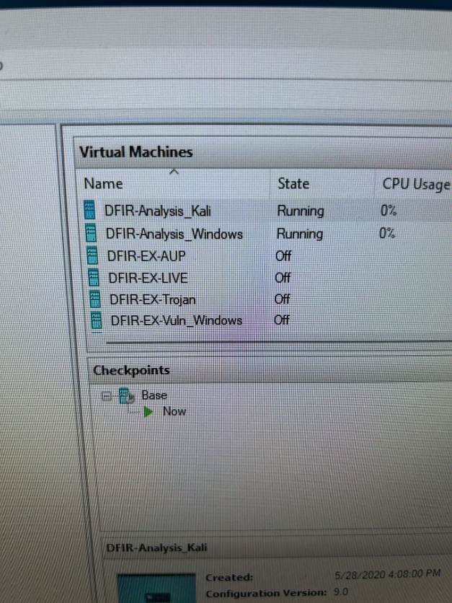
After: after we replace the burned board all get fixed
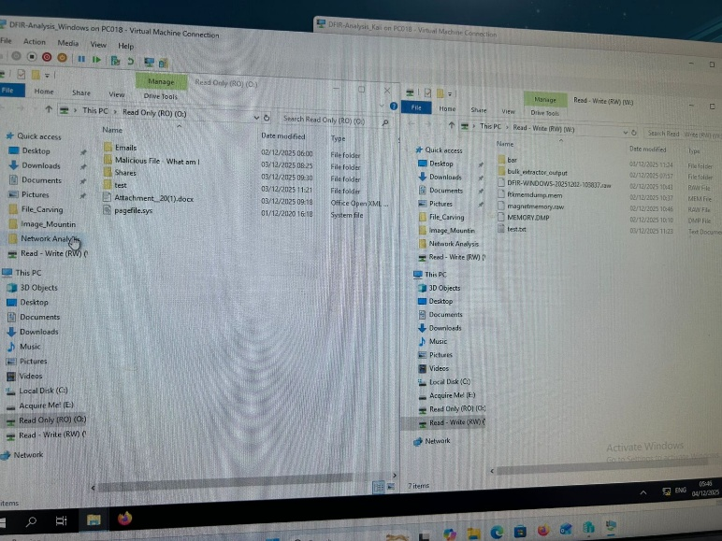
During this phase also we do the following:
- Logs were preserved
- Hardware condition was documented
- Actions were recorded
- Evidence was handled according to procedures

P6: Communicate incident status and impacts to internal stakeholders and regulatory bodies as required.
We do a report and document that incident and escalated to the manager Ahmad ghnemait to buy brand new board instead of the burned one so all these was done and have been sent to Ahmad:
- Suspected attack
- System unavailability
- Investigation status
- Recovery decision
Ahmad was informed by email and report of the team suspicious of attack and he recommend to make sure of that and the email was include of the info of the system unavailability with deep investigation of the incident cause to find it which is the board also we sent a recommendation of the recovery.

P7: Support recovery actions to restore safe OT operations.
First we bought a new board put it instead of the burned and welding the part of the new board that was after research of this board cant handle the server it need more advanced one to do that that was the cause of incident.
Secondly we get the server back physically and reconnected and reconfigure it again to getting the server back to work.
My role I was helping with sitting the new board again in the server.
The team achievement was:
- Hardware repair was attempted
- Board replacement was required
- System was restored safely

P8: Validate recovered OT systems to confirm integrity, operational readiness, and alignment with safety baselines.
we do the recovery next we validate it by implement these steps firstly, System integrity we sure everything in the server I integrated in the system specially the new board. Secondly, Check the configuration of the server to leads to Correct operation of services that by Restoration of OT communications of the system also make sure the Alignment with safety baselines.
Before all these step which is the important one implement a Test plan on the functionality of the server, Only after validation was the system returned to full operational use.
Evidence:


P9: Document incident findings and lessons learned in accordance with organisational and regulatory processes.
Throw the incident and after it there’s more than 5 reported has been written and here’s the reports:
- Incident timeline
- Forensic findings
- Communication report to Ahmad
- Recovery actions taken
- Root cause Analysis (suspected cyber activity with confirmed hardware failure)
- Lessons learned
The effect of the incidents and the actual benefits of these report are These reports facilitates organizational learning and compliance needs, also do organized work that make avoiding any incoming incident that similar and to sent it to the top manager so it should be organized and in formal way.

P10: Review incident-response processes to identify improvement opportunities.
That the benefits of the incident report t to evaluate the response operations is it based on knowledge or it’s based on uncertainty and we do like a SWOT analysis to Identify and pros and cons of the incident and here’s some of the improvement opportunities of the incident:
- Improved hardware health monitoring
- Faster escalation procedures
- Availability of spare components
- Enhanced forensic readiness for OT systems
These improvements were recommended to strengthen future OT incident response.

